Bootstrap 4
If you don't want to download and host Bootstrap 4 yourself, you can include it from a CDN (Content Delivery Network).
MaxCDN provides CDN support for Bootstrap's CSS and JavaScript. You must also include jQuery:

<!-- Latest compiled and minified CSS -->
<link rel="stylesheet" href="https://maxcdn.bootstrapcdn.com/bootstrap/4.5.0/css/bootstrap.min.css">
<!-- jQuery library -->
<script src="https://ajax.googleapis.com/ajax/libs/jquery/3.5.1/jquery.min.js"></script>
<!-- Popper JS -->
<script src="https://cdnjs.cloudflare.com/ajax/libs/popper.js/1.16.0/umd/popper.min.js"></script>
<!-- Latest compiled JavaScript -->
<script src="https://maxcdn.bootstrapcdn.com/bootstrap/4.5.0/js/bootstrap.min.js"></script>

Grid Options
列表如下。
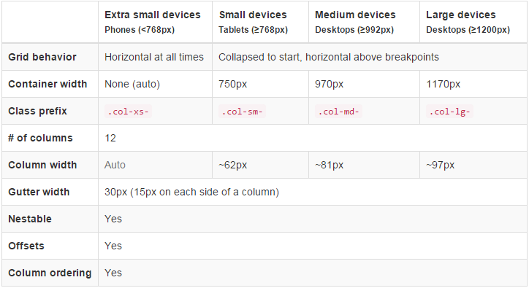
因此我們可以依此做基本的設定，在 Desktop 的結果如下：
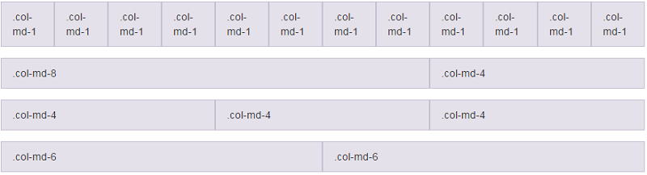
規則
Grid System 是經由 Row（列）和 Column（行）來建立頁面的架構的，然後再將內容裝在這些由 Row（列）和 Column（行）組成的框框裡面。
簡述規則如下：
- class 的結構依序為：
.container（固定寬度）或 .container-fluid -> .row -> Column。.container 或 .container-fluid 讓版面有適當的對齊方式（alignment）和間格（padding）。
- 使用水平方向的 .row 來群組 Column。
- 內容放在 Column 之內，且 Column 一定緊接在 .row 之下，是為 Immediate Children。
- 使用 class .row 或 .col-xs-4 來建立頁面的架構，也可以使用 Less mixins and variables 來做設定或調整。
- Column 為最小單位的方格，且有間格將彼此格開，並由 .row 使用負的 margin 值校正因 Column 而多出來的左右 padding。
- 指定 Column 的格數（最多到 12），例如一列希望有 3 個相等的 Column，可指定 3 個 .col-xs-4。
- 基本上一個 Row 放置 12 個 Column，若有一個 Row 超過 12 個 Column，則會斷行放置多出來的 Column。
- 使用 Grid Class 會影響到大於或等於設定分段點的 Device，例如：使用 .col-md-* 不僅會影響到 Desktop，若沒有設定 .col-lg-*，還會影響到 Large Desktop。
Media Queries 的分段點
- .col- (extra small devices - screen width less than 576px)
- .col-sm- (small devices - screen width equal to or greater than 576px)
- .col-md- (medium devices - screen width equal to or greater than 768px)
- .col-lg- (large devices - screen width equal to or greater than 992px)
- .col-xl- (xlarge devices - screen width equal to or greater than 1200px)

Bootstrap 4 Table
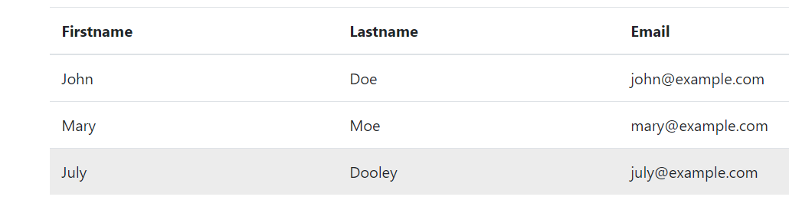
<!DOCTYPE html>
<html lang="en">
<head>
<title>Bootstrap Example</title>
<meta charset="utf-8">
<meta name="viewport" content="width=device-width, initial-scale=1">
<link rel="stylesheet" href="https://maxcdn.bootstrapcdn.com/bootstrap/4.5.0/css/bootstrap.min.css">
<script src="https://ajax.googleapis.com/ajax/libs/jquery/3.5.1/jquery.min.js"></script>
<script src="https://cdnjs.cloudflare.com/ajax/libs/popper.js/1.16.0/umd/popper.min.js"></script>
<script src="https://maxcdn.bootstrapcdn.com/bootstrap/4.5.0/js/bootstrap.min.js"></script>
</head>
<body>

<div class="container">
<h2>Hover Rows</h2>
<p>The .table-hover class enables a hover state (grey background on mouse over) on table rows:</p>
<table class="table table-hover">
<thead>
<tr>
<th>Firstname</th>
<th>Lastname</th>
<th>Email</th>
</tr>
</thead>
<tbody>
<tr>
<td>John</td>
<td>Doe</td>
<td>john@example.com</td>
</tr>
<tr>
<td>Mary</td>
<td>Moe</td>
<td>mary@example.com</td>
</tr>
<tr>
<td>July</td>
<td>Dooley</td>
<td>july@example.com</td>
</tr>
</tbody>
</table>
</div>
</body>
</html>

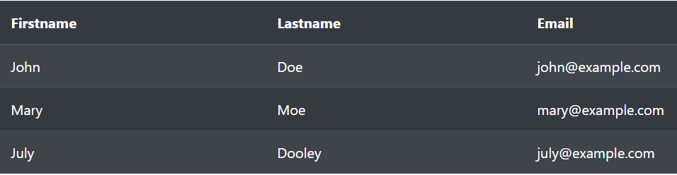
<!DOCTYPE html>
<html lang="en">
<head>
<title>Bootstrap Example</title>
<meta charset="utf-8">
<meta name="viewport" content="width=device-width, initial-scale=1">
<link rel="stylesheet" href="https://maxcdn.bootstrapcdn.com/bootstrap/4.5.0/css/bootstrap.min.css">
<script src="https://ajax.googleapis.com/ajax/libs/jquery/3.5.1/jquery.min.js"></script>
<script src="https://cdnjs.cloudflare.com/ajax/libs/popper.js/1.16.0/umd/popper.min.js"></script>
<script src="https://maxcdn.bootstrapcdn.com/bootstrap/4.5.0/js/bootstrap.min.js"></script>
</head>
<body>

<div class="container">
<h2>Dark Striped Table</h2>
<p>Combine .table-dark and .table-striped to create a dark, striped table:</p>
<table class="table table-dark table-striped">
<thead>
<tr>
<th>Firstname</th>
<th>Lastname</th>
<th>Email</th>
</tr>
</thead>
<tbody>
<tr>
<td>John</td>
<td>Doe</td>
<td>john@example.com</td>
</tr>
<tr>
<td>Mary</td>
<td>Moe</td>
<td>mary@example.com</td>
</tr>
<tr>
<td>July</td>
<td>Dooley</td>
<td>july@example.com</td>
</tr>
</tbody>
</table>
</div>
</body>
</html>

Class Description
.table-primary Blue: Indicates an important action
.table-success Green: Indicates a successful or positive action
.table-danger Red: Indicates a dangerous or potentially negative action
.table-info Light blue: Indicates a neutral informative change or action
.table-warning Orange: Indicates a warning that might need attention
.table-active Grey: Applies the hover color to the table row or table cell
.table-secondary Grey: Indicates a slightly less important action
.table-light Light grey table or table row background
.table-dark Dark grey table or table row background
…
<tr class="table-success">
<td>Success</td>
<td>Doe</td>
<td>john@example.com</td>
</tr>
…
.table-responsive class adds a scrollbar to the table when needed (when it is too big horizontally):
<div class="table-responsive">
<table class="table">
...
</table>
</div>

Bootstrap 4 Image Shapes

<img src="cinqueterre.jpg" class="rounded" alt="Cinque Terre">
<img src="cinqueterre.jpg" class="rounded-circle" alt="Cinque Terre">
<img src="cinqueterre.jpg" class="img-thumbnail" alt="Cinque Terre">

Button Style
<button type="button" class="btn">Basic</button>
<button type="button" class="btn btn-primary">Primary</button>
<button type="button" class="btn btn-secondary">Secondary</button>
<button type="button" class="btn btn-success">Success</button>
<button type="button" class="btn btn-info">Info</button>
<button type="button" class="btn btn-warning">Warning</button>
<button type="button" class="btn btn-danger">Danger</button>
<button type="button" class="btn btn-dark">Dark</button>
<button type="button" class="btn btn-light">Light</button>
<button type="button" class="btn btn-link">Link</button>

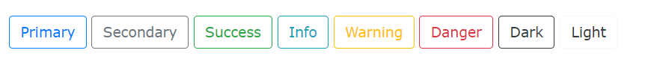
<button type="button" class="btn btn-outline-primary">Primary</button>
<button type="button" class="btn btn-outline-secondary">Secondary</button>
<button type="button" class="btn btn-outline-success">Success</button>
<button type="button" class="btn btn-outline-info">Info</button>
<button type="button" class="btn btn-outline-warning">Warning</button>
<button type="button" class="btn btn-outline-danger">Danger</button>
<button type="button" class="btn btn-outline-dark">Dark</button>
<button type="button" class="btn btn-outline-light text-dark">Light</button>

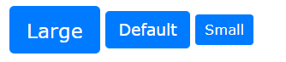
<button type="button" class="btn btn-primary btn-lg">Large</button>
<button type="button" class="btn btn-primary">Default</button>
<button type="button" class="btn btn-primary btn-sm">Small</button>


<button class="btn btn-primary">
<span class="spinner-border spinner-border-sm"></span>
</button>
<button class="btn btn-primary">
<span class="spinner-border spinner-border-sm"></span>
Loading..
</button>
<button class="btn btn-primary" disabled>
<span class="spinner-border spinner-border-sm"></span>
Loading..
</button>
<button class="btn btn-primary" disabled>
<span class="spinner-grow spinner-grow-sm"></span>
Loading..
</button>

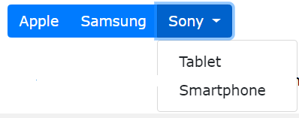
<div class="btn-group">
<button type="button" class="btn btn-primary">Apple</button>
<button type="button" class="btn btn-primary">Samsung</button>
<div class="btn-group">
<button type="button" class="btn btn-primary dropdown-toggle" data-toggle="dropdown">
Sony
</button>
<div class="dropdown-menu">
<a class="dropdown-item" href="#">Tablet</a>
<a class="dropdown-item" href="#">Smartphone</a>
</div>
</div></div>

<div class="btn-group-vertical">
<button type="button" class="btn btn-primary">Apple</button>
<button type="button" class="btn btn-primary">Samsung</button>
<div class="btn-group">
<button type="button" class="btn btn-primary dropdown-toggle" data-toggle="dropdown">
Sony
</button>
<div class="dropdown-menu">
<a class="dropdown-item" href="#">Tablet</a>
<a class="dropdown-item" href="#">Smartphone</a>
</div>
</div>
</div>


<div class="spinner-border text-muted"></div>
<div class="spinner-border text-primary"></div>
<div class="spinner-border text-success"></div>
<div class="spinner-border text-info"></div>
<div class="spinner-border text-warning"></div>
<div class="spinner-border text-danger"></div>
<div class="spinner-border text-secondary"></div>
<div class="spinner-border text-dark"></div>
<div class="spinner-border text-light"></div>

Pagination
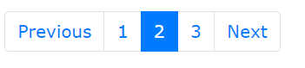
<ul class="pagination">
<li class="page-item"><a class="page-link" href="#">Previous</a></li>
<li class="page-item"><a class="page-link" href="#">1</a></li>
<li class="page-item active"><a class="page-link" href="#">2</a></li>
<li class="page-item"><a class="page-link" href="#">3</a></li>
<li class="page-item"><a class="page-link" href="#">Next</a></li>
</ul>

<ul class="pagination pagination-lg">
<li class="page-item"><a class="page-link" href="#">Previous</a></li>
<li class="page-item"><a class="page-link" href="#">1</a></li>
<li class="page-item"><a class="page-link" href="#">2</a></li>
<li class="page-item"><a class="page-link" href="#">3</a></li>
<li class="page-item"><a class="page-link" href="#">Next</a></li>
</ul>

<ul class="pagination pagination-sm">
<li class="page-item"><a class="page-link" href="#">Previous</a></li>
<li class="page-item"><a class="page-link" href="#">1</a></li>
<li class="page-item"><a class="page-link" href="#">2</a></li>
<li class="page-item"><a class="page-link" href="#">3</a></li>
<li class="page-item"><a class="page-link" href="#">Next</a></li>
</ul>

Dropdown
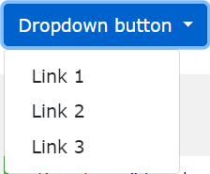
<div class="dropdown">
<button type="button" class="btn btn-primary dropdown-toggle" data-toggle="dropdown">
Dropdown button
</button>
<div class="dropdown-menu">
<a class="dropdown-item" href="#">Link 1</a>
<a class="dropdown-item" href="#">Link 2</a>
<a class="dropdown-item" href="#">Link 3</a>
</div>
</div>

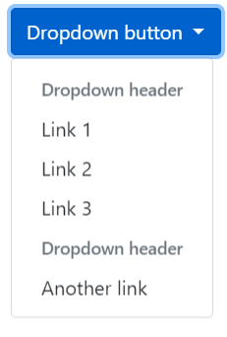
<div class="container">
<h2>Dropdowns</h2>
<p>The .dropdown-header class is used to add headers inside the dropdown menu:</p>
<div class="dropdown">
<button type="button" class="btn btn-primary dropdown-toggle" data-toggle="dropdown">
Dropdown button
</button>
<div class="dropdown-menu">
<h5 class="dropdown-header">Dropdown header</h5>
<a class="dropdown-item" href="#">Link 1</a>
<a class="dropdown-item" href="#">Link 2</a>
<a class="dropdown-item" href="#">Link 3</a>
<h5 class="dropdown-header">Dropdown header</h5>
<a class="dropdown-item" href="#">Another link</a>
</div>
</div>
</div>

Form
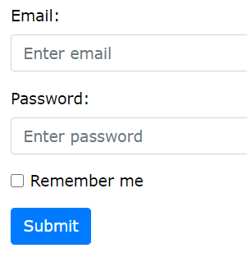
<form action="">
<div class="form-group">
<label for="email">Email address:</label>
<input type="email" class="form-control" placeholder="Enter email" id="email">
</div>
<div class="form-group">
<label for="pwd">Password:</label>
<input type="password" class="form-control" placeholder="Enter password" id="pwd">
</div>
<div class="form-group form-check">
<label class="form-check-label">
<input class="form-check-input" type="checkbox"> Remember me
</label>
</div>
<button type="submit" class="btn btn-primary">Submit</button>
</form>

You can use different validation classes to provide valuable feedback to users.
Add either .was-validated or .needs-validation to the <form> element, depending on whether you want to provide validation feedback before or after submitting the form. The input fields will have a green (valid) or red (invalid) border to indicate what's missing in the form. You can also add a .valid-feedback or .invalid-feedback message to tell the user explicitly what's missing, or needs to be done before submitting the form.

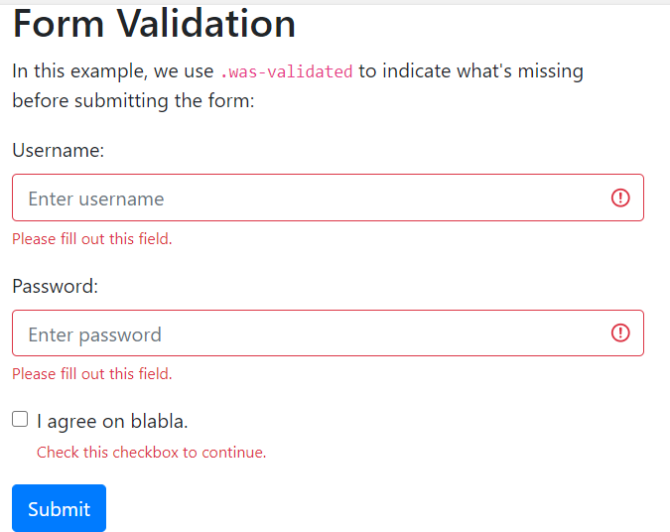
<form action="" class="was-validated">
<div class="form-group">
<label for="uname">Username:</label>
<input type="text" class="form-control" id="uname" placeholder="Enter username" name="uname" required>
<div class="valid-feedback">Valid.</div>
<div class="invalid-feedback">Please fill out this field.</div>
</div>
<div class="form-group">
<label for="pwd">Password:</label>
<input type="password" class="form-control" id="pwd" placeholder="Enter password" name="pswd" required>
<div class="valid-feedback">Valid.</div>
<div class="invalid-feedback">Please fill out this field.</div>
</div>
<div class="form-group form-check">
<label class="form-check-label">
<input class="form-check-input" type="checkbox" name="remember" required> I agree on blabla.
<div class="valid-feedback">Valid.</div>
<div class="invalid-feedback">Check this checkbox to continue.</div>
</label>
</div>
<button type="submit" class="btn btn-primary">Submit</button>
</form>

In this example, we use .needs-validation, which will add the validation effect AFTER the form has been submitting (if there's anything missing). Note that you will also have to add some jQuery code for this example to work properly:

<form action="" class="needs-validation" novalidate>
<div class="form-group">
<label for="uname">Username:</label>
<input type="text" class="form-control" id="uname" placeholder="Enter username" name="uname" required>
<div class="valid-feedback">Valid.</div>
<div class="invalid-feedback">Please fill out this field.</div>
</div>
<div class="form-group">
<label for="pwd">Password:</label>
<input type="password" class="form-control" id="pwd" placeholder="Enter password" name="pswd" required>
<div class="valid-feedback">Valid.</div>
<div class="invalid-feedback">Please fill out this field.</div>
</div>
<div class="form-group form-check">
<label class="form-check-label">
<input class="form-check-input" type="checkbox" name="remember" required> I agree on blabla.
<div class="valid-feedback">Valid.</div>
<div class="invalid-feedback">Check this checkbox to continue.</div>
</label>
</div>
<button type="submit" class="btn btn-primary">Submit</button>
</form>

<script>
// Disable form submissions if there are invalid fields
(function() {
'use strict';
window.addEventListener('load', function() {
// Get the forms we want to add validation styles to
var forms = document.getElementsByClassName('needs-validation');
// Loop over them and prevent submission
var validation = Array.prototype.filter.call(forms, function(form) {
form.addEventListener('submit', function(event) {
if (form.checkValidity() === false) {
event.preventDefault();
event.stopPropagation();
}
form.classList.add('was-validated');
}, false);
});
}, false);
})();
</script>

Create a Modal

<!-- Button to Open the Modal -->
<button type="button" class="btn btn-primary" data-toggle="modal" data-target="#myModal">
Open modal
</button>

<!-- The Modal -->
<div class="modal" id="myModal">
<div class="modal-dialog">
<div class="modal-content">

<!-- Modal Header -->
<div class="modal-header">
<h4 class="modal-title">Modal Heading</h4>
<button type="button" class="close" data-dismiss="modal">&times;</button>
</div>

<!-- Modal body -->
<div class="modal-body">
Modal body..
</div>

<!-- Modal footer -->
<div class="modal-footer">
<button type="button" class="btn btn-danger" data-dismiss="modal">Close</button>
</div>
</div>
</div>
</div>
NavBar
A standard navigation bar is created with the .navbar class, followed by a responsive collapsing class: .navbar-expand-xl|lg|md|sm (stacks the navbar vertically on extra large, large, medium or small screens).

To add links inside the navbar, use a <ul> element with class="navbar-nav". Then add <li> elements with a .nav-item class followed by an <a> element with a .nav-link class:

<nav class="navbar navbar-expand-sm bg-light">
<!-- Links -->
<ul class="navbar-nav">
<li class="nav-item">
<a class="nav-link" href="#">Link 1</a>
</li>
<li class="nav-item">
<a class="nav-link" href="#">Link 2</a>
</li>
<li class="nav-item">
<a class="nav-link" href="#">Link 3</a>
</li>
</ul>
</nav>

Colored Navbar
Use any of the .bg-color classes to change the background color of the navbar (.bg-primary, .bg-success, .bg-info, .bg-warning, .bg-danger, .bg-secondary, .bg-dark and .bg-light)

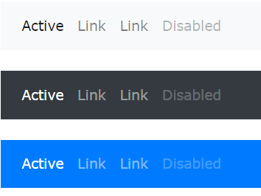
<!-- Grey with black text -->
<nav class="navbar navbar-expand-sm bg-light navbar-light">
<ul class="navbar-nav">
<li class="nav-item active">
<a class="nav-link" href="#">Active</a>
</li>
<li class="nav-item">
<a class="nav-link" href="#">Link</a>
</li>
<li class="nav-item">
<a class="nav-link" href="#">Link</a>
</li>
<li class="nav-item">
<a class="nav-link disabled" href="#">Disabled</a>
</li>
</ul>
</nav>

<!-- Black with white text -->
<nav class="navbar navbar-expand-sm bg-dark navbar-dark">...</nav>

<!-- Blue with white text -->
<nav class="navbar navbar-expand-sm bg-primary navbar-dark">...</nav>

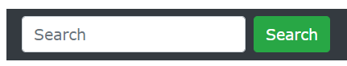

<nav class="navbar navbar-expand-sm bg-dark navbar-dark">
<form class="form-inline" action="/action_page.php">
<input class="form-control mr-sm-2" type="text" placeholder="Search">
<button class="btn btn-success" type="submit">Search</button>
</form>
</nav>

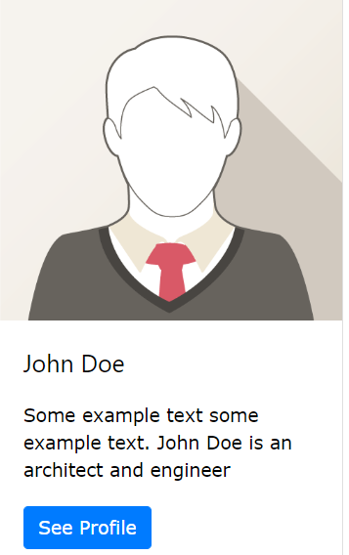
<div class="card" style="width:400px">
<img class="card-img-top" src="img_avatar1.png" alt="Card image">
<div class="card-body">
<h4 class="card-title">John Doe</h4>
<p class="card-text">Some example text.</p>
<a href="#" class="btn btn-primary">See Profile</a>
</div>
</div>

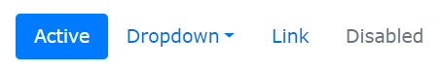
<ul class="nav nav-pills">
<li class="nav-item">
<a class="nav-link active" href="#">Active</a>
</li>
<li class="nav-item dropdown">
<a class="nav-link dropdown-toggle" data-toggle="dropdown" href="#">Dropdown</a>
<div class="dropdown-menu">
<a class="dropdown-item" href="#">Link 1</a>
<a class="dropdown-item" href="#">Link 2</a>
<a class="dropdown-item" href="#">Link 3</a>
</div>
</li>
<li class="nav-item">
<a class="nav-link" href="#">Link</a>
</li>
<li class="nav-item">
<a class="nav-link disabled" href="#">Disabled</a>
</li>
</ul>

Product JSON 顯示bootstrap分頁
<!DOCTYPE html>
<html>
<head>
<meta charset="UTF-8">
<title>jQuery Serialize</title>
<link rel="stylesheet" href="https://maxcdn.bootstrapcdn.com/bootstrap/4.5.0/css/bootstrap.min.css">
<!-- jQuery library -->
<script src="https://ajax.googleapis.com/ajax/libs/jquery/3.6.3/jquery.min.js"></script>
<!-- Popper JS -->
<script src="https://cdnjs.cloudflare.com/ajax/libs/popper.js/1.16.0/umd/popper.min.js"></script>
<!-- Latest compiled JavaScript -->
<script src="https://maxcdn.bootstrapcdn.com/bootstrap/4.5.0/js/bootstrap.min.js"></script>
</head>
<body>
<div class="container">
<button id="b1">Get Json</button>
<div class="row">
<div class="col-md-3">
<div class="card" style="width:100%">
<img class="card-img-top" style="height:300px" id="pic1" src="./images/pic.png" alt="Card image">
<div class="card-body">
<h4 class="card-title" id="title1">John Doe</h4>
<p class="card-text" id="desc1">Some example text.</p>
<a href="#" class="btn btn-primary">See Profile</a>
</div>
</div>
</div>
<div class="col-md-3">
<div class="card" style="width:100%">
<img class="card-img-top" style="height:300px" id="pic2" src="./images/pic.png" alt="Card image">
<div class="card-body">
<h4 class="card-title" id="title2">John Doe</h4>
<p class="card-text" id="desc2">Some example text.</p>
<a href="#" class="btn btn-primary">See Profile</a>
</div>
</div>
</div>
<div class="col-md-3">
<div class="card" style="width:100%">
<img class="card-img-top" style="height:300px" id="pic3" src="./images/pic.png" alt="Card image">
<div class="card-body">
<h4 class="card-title" id="title3">John Doe</h4>
<p class="card-text" id="desc3">Some example text.</p>
<a href="#" class="btn btn-primary">See Profile</a>
</div>
</div>
</div>
<div class="col-md-3">
<div class="card" style="width:100%">
<img class="card-img-top" style="height:300px" id="pic4" src="./images/pic.png" alt="Card image">
<div class="card-body">
<h4 class="card-title" id="title4">John Doe</h4>
<p class="card-text" id="desc4">Some example text.</p>
<a href="#" class="btn btn-primary">See Profile</a>
</div>
</div>
</div>
</div>
<div class="row">
<p></p>
<ul class="pagination" id="pg">
<li class="page-item"><a class="page-link" href="#">Previous</a></li>
<li class="page-item"><a class="page-link" href="#">1</a></li>
<li class="page-item active"><a class="page-link" href="#">2</a></li>
<li class="page-item"><a class="page-link" href="#">3</a></li>
<li class="page-item"><a class="page-link" href="#">Next</a></li>
</ul>
</div>
</div>
<script>
var pageCount=4;
var products=[];
function showCard(data,page) {
$("#pic1").attr("src",data[page*pageCount].image);
$("#pic2").attr("src",data[page*pageCount+1].image);
$("#pic3").attr("src",data[page*pageCount+2].image);
$("#pic4").attr("src",data[page*pageCount+3].image);
displayPage(data,page)

}
function displayPage(data,page){
$("#pg").empty();
var size=data.length;
console.log("size:"+size);
for (var i = 0; i < Math.ceil(size/pageCount); i++) {
//creating the page items
if(i==page)
$("#pg").append('<li class="page-item active"><a class="page-link" onclick="showCard(products,'+i+')">' + (i + 1) + '</a></li> ');
else
$("#pg").append('<li class="page-item"><a class="page-link" onclick="showCard(products,'+i+')">' + (i + 1) + '</a></li> ');

}
}

function result(data){
products=data;
showCard(data,0);
}
function check(evt){
$.get("https://fakestoreapi.com/products",result);
evt.preventDefault();
}
function start(){
$("#b1").click(check);
}
$(document).ready(start);
</script>
</body>
</html>

這段程式的功能是從一個假商店 API (`fakestoreapi.com/products`) 取得商品數據，然後將這些商品以每頁 4 張圖片的形式顯示，並透過分頁導航進行切換。以下是程式的詳細解釋：

1. **變數定義**：
- `pageCount=4`：定義每頁要顯示的商品數量，即 4 個。
- `products=[]`：宣告一個空陣列 `products`，將會儲存從 API 取得的商品數據。

2. **函數 `showCard(data, page)`**：
- 這個函數負責根據當前頁面顯示 4 張商品圖片。
- `data[page*pageCount].image`：這段程式會根據當前的頁數計算要顯示的商品圖片，並且把對應的圖片 URL 設定給 HTML 中的圖片元素（`#pic1`、`#pic2` 等）。
- `displayPage(data, page)`：呼叫另一個函數來顯示對應的分頁導航。

3. **函數 `displayPage(data, page)`**：
- 此函數負責產生分頁導航（即頁數按鈕），並顯示當前頁數。
- `$("#pg").empty();`：清空現有的分頁導航。
- `Math.ceil(size/pageCount)`：計算總頁數，這裡會根據 `data.length`（商品數量）除以 `pageCount`，並使用 `Math.ceil()` 向上取整。
- 迴圈中使用 `i==page` 檢查目前頁數，若是當前頁則加上 `active` 樣式來突出顯示。

4. **函數 `result(data)`**：
- 這個函數會在成功取得 API 資料後執行，將 API 回傳的數據儲存在 `products` 陣列，然後顯示第一頁內容（頁數 0）。

5. **函數 `check(evt)`**：
- 當按鈕被點擊時，會發出一個 GET 請求至 `https://fakestoreapi.com/products`，並呼叫 `result(data)` 來處理回傳的數據。
- `evt.preventDefault();`：防止按鈕的預設行為，例如表單提交。

6. **函數 `start()`**：
- 當頁面載入完成後，綁定按鈕（`#b1`）的點擊事件到 `check(evt)` 函數。

7. **`$(document).ready(start);`**：
- 當文件載入完成時，執行 `start()` 函數來初始化事件綁定。

### 總結：
這段程式會在點擊按鈕後，向 API 請求商品資料，並以每頁 4 張圖片的形式顯示商品。同時，程式會根據商品數量自動生成分頁按鈕，讓使用者可以透過點擊分頁按鈕來切換不同的商品頁面。

